PLEASE ANSWER ALL QUESTIONS. |  |  | Total 20 Marks
Question 1
A national toy distributor determines the cost and revenue models for one of its games.
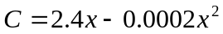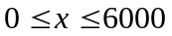
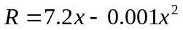
The profit function is defined by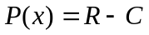. Analyze the profit function P over the specified interval, stating where the function is increasing and decreasing.
 |  | (4 marks)
Question 2
 |  | Determine the slope of tangent line to the graph of 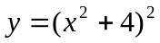when x=4.
 |  | (4 marks)
Question 3
Compute the derivative  of the following function:
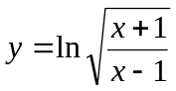
 |  | (4 marks)
Question 4
Calculate the following limits of the given functions:

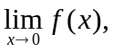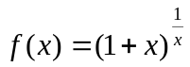

 |  | (3 marks)
Question 5
 |  | Determine the open intervals on which the function 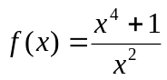is increasing or decreasing.
 |  | (5 marks)
 |  | **END OF QUESTIONS**

